Evan Eberhardt

2 April 2015

Lab Thursday 2:15

>> (3.7\*4+3\*5+2.3\*3)/(4+5+3)

ans =

3.0583

>> a=pi\*0.1\*[0:20];

>> cos(a)

ans =

Columns 1 through 10

1.0000 0.9511 0.8090 0.5878 0.3090 0.0000 -0.3090 -0.5878 -0.8090 -0.9511

Columns 11 through 20

-1.0000 -0.9511 -0.8090 -0.5878 -0.3090 -0.0000 0.3090 0.5878 0.8090 0.9511

>> t=0.1\*[0:5];

>> plot(t,exp(-t))

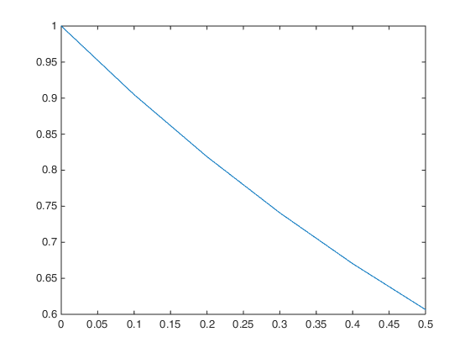

>> a=0.05\*pi\*[0:6];

>> plot(a,cos(a))

